**Goal:**

For this sprint we want to have a service provider be able to create a posting and have a service buyer be able to search for a post based on the service provided keyword

**Task Listing:**

**✅| User Story 0** - As a user I want to be able to create and sign into an account, So that my information is stored and accessible.

Task 1 (4 hours) - set up google auth and connect to firebase

Task 2 (1 hour) - make sure that after a user signs into the app once they do not have to sign in everytime that they open the app

* Most likely have to add in finishing stuff from sprint (ie google auth, and possibly hopefully not user profile storage in firebase )

✅ | [[spike]] **User Story 1** - as a team we want to design the shape of the database that stores the postings. So that we remain organized throughout the process

Task 1(.5 hours)

* brainstorm with team members about what a good architecture might look like

Task 2(.5 hours)

* implement and document the database shape

**✅ | User Story 2** - As a service provider I want to be able to create a post to advertise my services so that people looking for my services can see that I am providing them.

Task 1(2 hours)

* create a UI using swift UI, containing text boxes for necessary posting information like: service provided, location served, name, a picture, rate/cost of service.

Task 2 (.25 hours)

* Add post to database so that it can be pulled up at a later time.

**❌| User Story 3** - As a user I want to be able to see a page that contains listings and a search bar. So that I can quickly find the service I am looking for

Task 1(1 hour)

* Mockup in figma

Task 3(1 hours)

* Recall the posting data from the database so that you can create the display for it

Task 2 (3 hours)

* create the UI in swift with search bar, thumbnail posts and a scrollable feature

❌ | User Story 4 - As a user I want to be able to search for a service posting based on the keyword for the service. So that I will see only relevant results.

Task 1(free)

* Store search based on key word of service

Task 2(1 hour)

* Take that keyword and search the database for postings with that keyword in the service provided field of the posting

Task 3(3 hours)

* Pull the matching postings and display them to the UI (also make some message for postings not existing)

❌ | User Story 5 - As a user I want to be able to see a service providers profile page so that I can learn more about who that service provider is and what their rating is (implemented later)

Task 1 (1 hour)

* Figma mockup of profile page

Task 2 (2 hour)

* Pull up the necessary information from the database to fill out the user profile information to create the user profile page (pull up by username)

Task 3 (3 hours)

* Convert that user data into a viewable and useable page
* Create UI in swift of the profile page (in swift UI)
* include : name, picture, bio, rating, number of jobs completed, location served

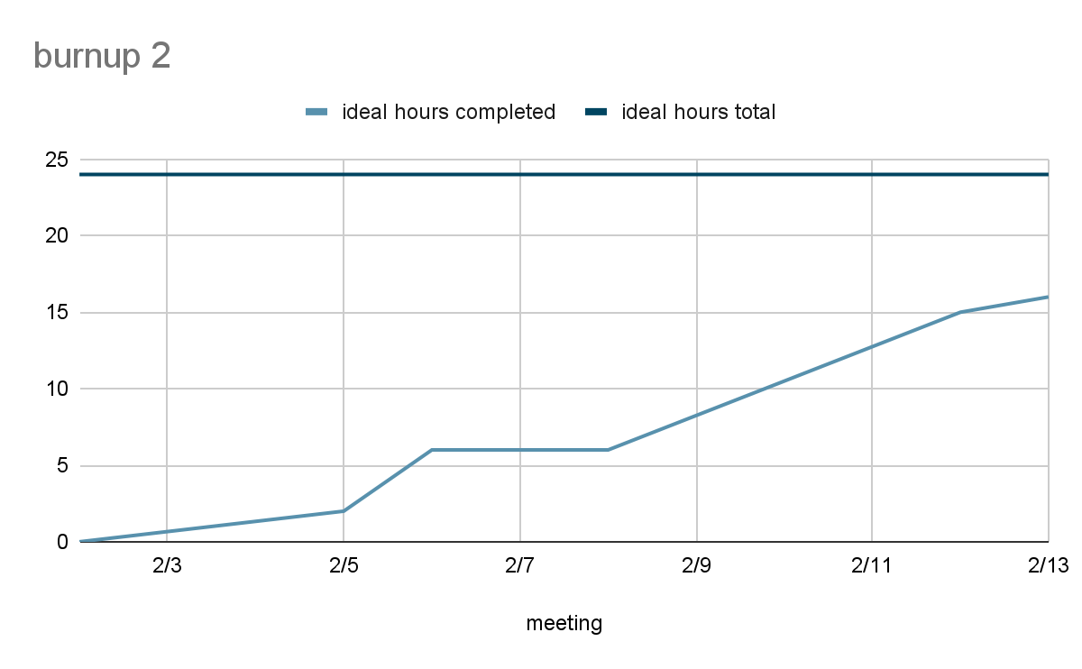

| Start | Stop | Continue |
| --- | --- | --- |
| Commenting code  Contributing to code base  Commit id on asana when done  Communicating on discord | Ignoring discord pings, they are important to the pinger… | Helping each other  Communicating  supporting |